1) In backend Dev. be aware of what you are doing with the data as the people can really screw things up like SQL Injection.

Be aware to test the data on entry points to prevent such attacks and leaks.

2) When your localhost URL is not working in Postman extension then use the pattern :

"IP Address:<port>/URL" like this : "192.168.29.159:8080/api/posts/2"

3) Setup Tricks:

1. To use the “node” command to start the server with the filename as “server.js” make the following changes in **package.json** file :

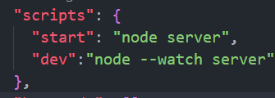

Here the “start” : “node server” helps you to use the “node server.js” command to start the server and the “dev” : “node –watch server” command helps in making the changes display concurrently while development otherwise you had to restart the server after making even a small change.

1. After adding the .env file for storing port numbers or API keys , you should modify the above ‘dev’ option like this :

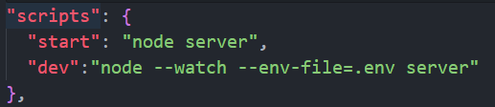

4) When setting up different files for the routes and linking them from server.js using the middleware functions then you have to change the .get() method arguments to ensure proper URL, like this :

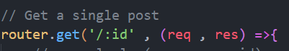

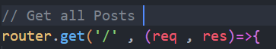

The above changes were made because the preceding part of the URL has already been declared in the server.js like:  
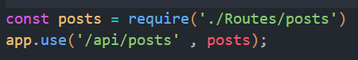

5) When you are going to use the express syntax instead of common js then make add this “type” attribute in the **package.json** file under the “main” attribute like:

